Feel the softness of touch By: Sophia Trykolenko
In the past years, Ukrainian artists, painters and designers, have brashly emerged on the global stage. It’s natural, since they have some inimitable originality in their way of thinking and plenty of creative ideas. And it is very pleasant that the world is opened to perceive and understand them. And also to wear from Ukrainian designers we hope… This article has an intention to introduce you to a young and talented fashion and accessories designer Tatka Ustymenko.
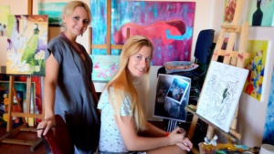
Despite her professional sphere of interests is very broad – she works in batik, fashion design, monumental and easel painting, and even icon painting – her main passion has always been fashion. And her priorities are women wedding and evening clothing, accessories, lingerie, batik and silk painting, pictorial art.
The search for beauty has become the inalienable part of the young Kyiv artist Tatka Ustymenko. Since early childhood Tatka has been reaching for recreation in her works the most complicate nuances of nature, tiny mystic coloring of fairy-tales, myths and legends. During her studying in The State Art Secondary School named after Taras Shevchenko the painter has learned the bases of academicals painting, the higher art education she has received at the Kyiv State Institute of Decorative and Applied Art named after Michael Boychuck. For six years Tatka had been studying the art of fashion design, receiving the qualification of fashion designer, specialist of “Artistic costume modeling”. Also she has the second degree “The artist of decorative and applied art”.
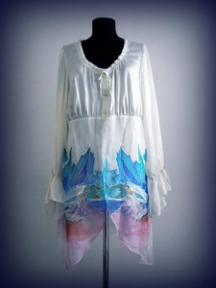 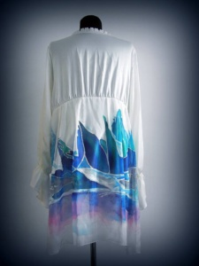 In her art pieces Tatka Ustymenko strives the decorative stylization: the costume sketches, portraits, landscapes, still lives, the works on mythological subjects have vivid coloring, a lot of small details. The local spots are bordering with the smallest ornamental elements that decorate the costumes, objects, architectural constructions.
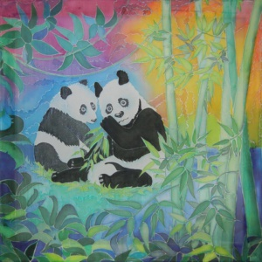 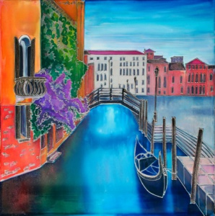 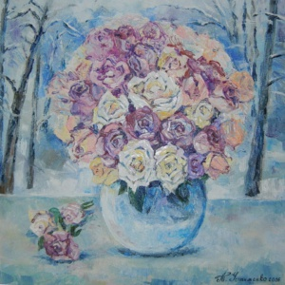Practicing vocals, Tatka brings in the elements of music into the costumes. The light, flying textiles are bordering with harsh sometimes rough textures, creating an unique duet of soprano and bass.
It should be mentioned that the art of making clothes is indissolubly connected with the art of decorating fabrics. One cannot be imagined without the other. In her art Tatka combines elegant style with batik painted fabric, creating the unforgettable summer images. The artist bases her art on the principles of classical painting fabrics. There are numerous easel and applied work in her art that became a kind of experimental ground for mastering techniques of painting silk and finding the painter's own handwriting.
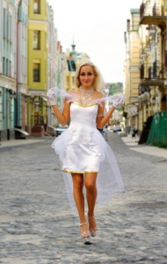 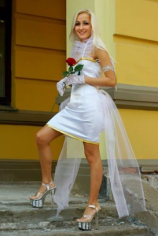 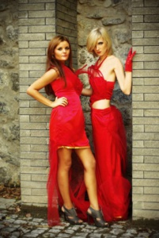The artist also maintains active exhibitions activity, in her list there are many exhibitions in Ukraine and abroad, Tatka takes part in fashion shows. She seeks to development. Never stops on what she has reached. The eternal search of beauty, harmony and the ideal correlation of elements in the single composition or costumes has become the main theme of her work. The art of Tatka Ustymenko may be called “the artistic materialization of music”, being so original and unique as the melody of the spring forest.
Tatka does not create clothes, she actually creates art that you can wear, feast your eyes, feel the softness of touch and listen to the music of your soul.
